Partnership Agreement and Provision

of Online Platform Services

Between
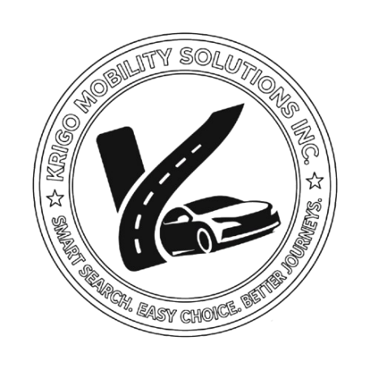

First party: ____________________  Electronic Platform: ____________________  Represented by: ____________________  Commercial Registration N: _____________  Address: ____________________  ____________________ | Second party: ____________________  Car Rental Agency: ____________________  Represented by: ____________________  Commercial Registration N: ____________  Address: ____________________  ____________________

Article 1: Purpose of the Agreement
This Agreement aims to regulate the relationship between the Parties, whereby the First Party (the Platform) shall:
Provide electronic services consisting of displaying the Second Party’s car rental services through a digital platform and enabling customers to view offers, communicate with the agency, and make reservations.
It is expressly acknowledged that:
- The First Party acts solely as a technical intermediary.
- The First Party does not own, rent, or manage vehicles.

Article 2: Nature of the Legal Relationship
The Parties agree that:
- Their relationship is a commercial / digital services relationship.
- The First Party shall not be considered:
  - A car rental agency; or
  - A party to any rental agreement concluded with customers.
All rental agreements shall be entered into directly between:
The Agency (Second Party) and the Customer.

Article 3: Obligations of the First Party
The First Party undertakes to:
- Display the Agency’s information and vehicles on the Platform.
- Provide a digital interface for reservations or service requests.
- Improve the visibility of offers within the Platform.
- Provide a communication system between customers and the Agency.
- Refrain from participating in the delivery or return of vehicles.
The First Party shall bear no responsibility for:
- Vehicle condition;
- Accidents;
- Mechanical failures;
- Misuse of vehicles.

Article 4: Obligations of the Second Party
The Second Party undertakes to:
- Provide accurate information regarding vehicles and prices.
- Ensure that all vehicles are:
  - Legally compliant;
  - Properly insured;
  - Fit for use.
- Comply with rental agreements concluded with customers.
- Assume full legal responsibility for the services provided.
- Regularly update information displayed on the Platform.

Article 5: Commission (If Applicable)
The Parties agree that:
- The Platform shall receive a commission of _____%; or
- A fixed amount of __________ per reservation.
Payment Method:
- Bank Transfer / CCP / Electronic Payment Method
Payment Schedule:
- Weekly / Monthly / After Each Reservation

Article 6: Platform Liability
The Platform shall not be liable for:
- Agreements concluded between the Agency and customers;
- Direct payments between the parties;
- Damages, disputes, or accidents.
The Platform serves solely as:
A technical intermediary for the display of information.

Article 7: Agency Liability
The Agency shall bear sole responsibility for:
- Any accident or damage;
- Any legal violation;
- Any dispute with customers;
- The accuracy of the information provided.

Article 8: Compliance with Laws
Both Parties undertake to comply with:
- Algerian Commercial Law;
- Electronic Commerce Law No. 18-05;
- Consumer Protection Law;
- Applicable transportation and insurance regulations.

Article 9: Term of the Agreement
The duration of this Agreement shall be:
- Indefinite, with the possibility of termination upon thirty (30) days' prior notice.

Article 10: Termination
Either Party may terminate this Agreement provided that:
- Thirty (30) days’ prior written notice is given; and
- All outstanding financial obligations are settled.

Article 11: Confidentiality
Both Parties undertake not to:
- Disclose users’ data;
- Or use such data outside the scope of the Platform.

Article 12: Dispute Resolution
In the event of a dispute:
- The Parties shall first seek an amicable settlement.
- If no settlement can be reached, the dispute shall be submitted to the competent courts having jurisdiction over the registered office of the First Party (the Platform).

Article 13: General Provisions
- This Agreement constitutes the entire agreement between the Parties.
- Any amendment must be made in writing.
- Any provision found to be unlawful or unenforceable shall be severed without affecting the validity of the remainder of the Agreement.

Signatures
First Party (Platform):  ____________________ | Second Party (Agency):  ____________________

Date: ____ / ____ / ______

